**SCD Lab 09**

**Name:** Hafsa Salman

**Roll no.** 22K-5161

**DBUtil Class:**

Code:

//Hafsa Salman  
//22K-5161  
//SCD Lab 09  
  
import java.sql.Connection;  
import java.sql.DriverManager;  
import java.sql.SQLException;  
  
public class DBUtil  
{  
 private static final String *URL* = "jdbc:oracle:thin:@localhost:1521:xe";  
 private static final String *USER* = "system";  
 private static final String *PASSWORD* = "abc123";  
  
 public static Connection getConnection() throws SQLException  
 {  
 try  
 {  
  
 Class.*forName*("oracle.jdbc.OracleDriver");  
 System.*out*.println("Oracle JDBC Driver Loaded Successfully!");  
 }  
  
 catch (ClassNotFoundException e)  
 {  
 System.*out*.println("Failed to load Oracle JDBC Driver");  
 e.printStackTrace();  
 }  
  
 return DriverManager.*getConnection*(*URL*, *USER*, *PASSWORD*);  
 }  
}

//Testing if the connection is successful or not

//Hafsa Salman  
//22K-5161  
//Testing DBUtil Class  
  
import java.sql.Connection;  
import java.sql.SQLException;  
  
public class Test  
{  
 public static void main(String[] args)  
 {  
 System.*out*.println("Name: Hafsa Salman");  
 System.*out*.println("Roll no. 22K-5161");  
 System.*out*.println("Testing DBUtil Class");  
 System.*out*.println();  
  
 try  
 {  
 Connection connection = DBUtil.*getConnection*();  
 if (connection != null)  
 {  
 System.*out*.println("Connection Successful!");  
 connection.close();  
 }  
 }  
  
 catch(SQLException e)  
 {  
 System.*out*.println("Connection Failed!");  
 e.printStackTrace();  
 }  
 }  
}

Output:

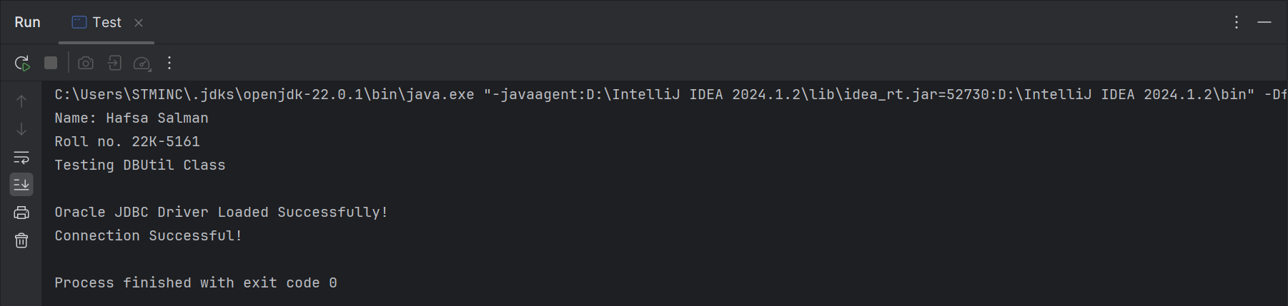

**Index.jsp**

Code:

<!--  
Hafsa Salman  
22K-5161  
SCD Lab 09  
-->  
  
<html>  
<head>  
 <title>22K-5161: SCD Lab 09</title>  
</head>  
<body>  
<h2>22K-5161: SCD Lab 09</h2>  
<p>Welcome to the SCD Lab 09. Click <a href = 'Continue.jsp'>here</a> to continue!</p>  
</body>  
</html>

Output:

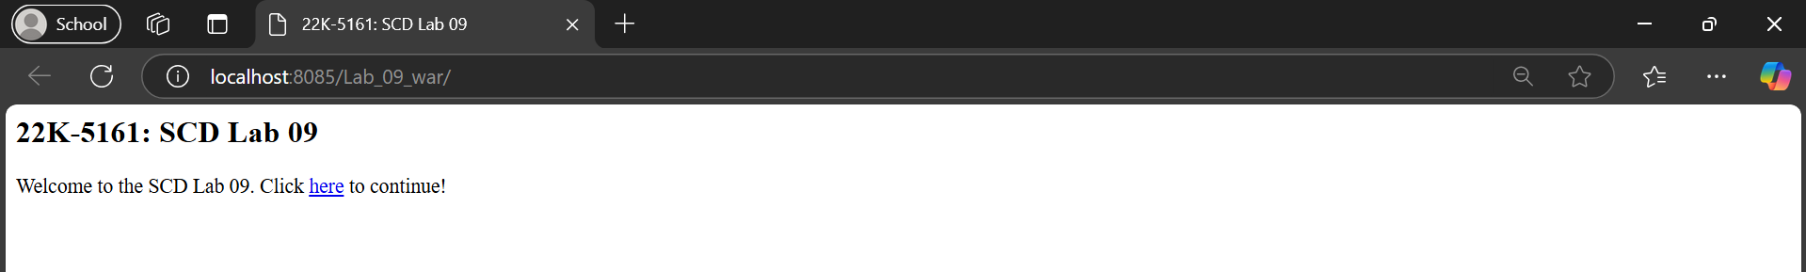

**Continue.jsp**

Code:

<!--  
Hafsa Salman  
22K-5161  
Continue.jsp  
-->  
  
<%@ **page** contentType="text/html;charset=UTF-8" language="java" %>  
<!DOCTYPE html>  
<html>  
<head>  
 <title>22K-5161: SCD Lab 09</title>  
 <style>  
 body  
 {  
 display: flex;  
 justify-content: center;  
 align-items: center;  
 height: 100vh;  
 margin: 0;  
 }  
  
 .container  
 {  
 text-align: center;  
 }  
  
 .button-container  
 {  
 display: flex;  
 justify-content: center;  
 gap: 20px;  
 margin-top: 20px;  
 }  
  
 .button  
 {  
 padding: 10px 20px;  
 text-decoration: none;  
 border: 1px solid black;  
 background-color: lightgray;  
 color: black;  
 border-radius: 5px;  
 }  
 </style>  
</head>  
<body>  
<div class="container">  
 <h2>22K-5161: SCD Lab 09</h2>  
 <div class="button-container">  
 <a href="createUser.jsp" class="button">Create Account</a>  
 <a href="manageUsers.jsp" class="button">Manage Users</a>  
 </div>  
</div>  
</body>  
</html>

Output:

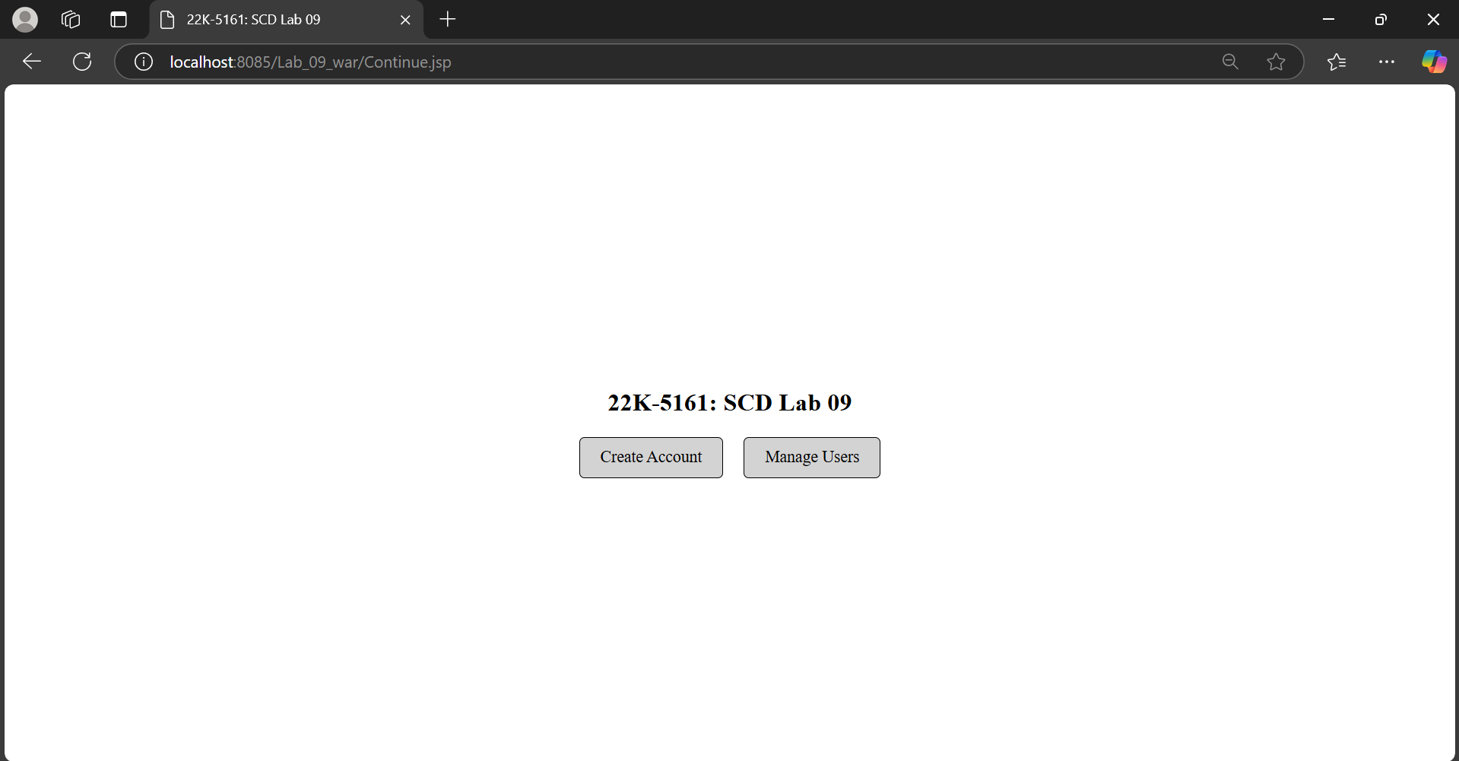

**createUser.jsp**

Code:

Output:

**Index.jsp**

Code:

Output:

**Index.jsp**

Code:

Output: